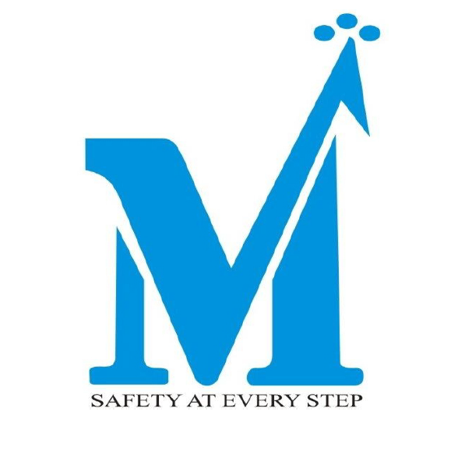

**MAYUR LEATHER PRODUCTS LIMITED**

**VIGIL MECHANISM/ WHISTLE BLOWER POLICY**

# Preface

Mayur Leather Products Limited (herein after referred as “MLPL”) being listed company requires to establish a vigil mechanism for Directors and employees to report the genuine concerns as per the provisions of the section 177 of the Companies Act, 2013 and Regulation 22 of the SEBI (Listing Obligations and Disclosure Requirements) Regulations, 2015 in such manner as may be prescribed.

In terms of Regulation 4(2)(d) of SEBI (Listing Obligations and Disclosure Requirements) Regulations, 2015 (“SEBI LODR”), it is mandatory requirement for all listed companies to devise an effective whistle blower mechanism enabling stakeholders, including individual employees and their representative bodies to freely communicate their concerns about

illegal or unethical practices.

MLPL has adopted a Code of Conduct (“the Code”) for Directors and senior management, which lays down the principles and standards that should govern the action of the Company and its employees.

In view of the above, MLPL , being a listed company has established a Vigil Mechanism and

formulated a Whistle Blower Policy for BFIL and its subsidiaries.

# Policy Objectives

Vigil Mechanism aims to provide a channel to the Directors and employees to report genuine concerns about unethical behaviour, actual or suspected fraud or violation of the Standards, Code of Conduct or policy adopted by the Company from time to time.

The Company is committed to adhere to the highest standards of ethical, moral and legal conduct of business operations and in order to maintain these standards, the Company encourages its employees who have genuine concerns about suspected misconduct to come forward and express these concerns without fear of punishment or unfair treatment.

The mechanism provides for adequate safeguards against victimization of Directors and employees to avail of the mechanism and also provide for direct access to the Vigilance Officer.

This neither releases employee from their duty of confidentiality in the course of their work nor can it be used as a route for raising malicious or unfounded allegations about a personal situation.

# Definitions

The definitions of some of the key terms used in this Policy are given below.

1. **““Audit Committee”** means a Committee constituted by the Board of Directors of the Company in accordance with regulations of SEBI LODR and Companies Act, 2013.
2. **“Board”** means the Board of Directors of the Company.
3. **“Company”** means the Mayur Leather Products Limitedand its subsidiaries.
4. **“Employee”** means all the present employees and Directors of the Company

(Whether working in India or abroad).

1. **“Protected Disclosure”** means any communication in good faith that discloses or demonstrates information that may evidence unethical or improper activity.
2. **“Subject”** means a person or group of persons against or in relation to whom a Protected is closure is made or evidence gathered during the course of an investigation.

1. **“Vigilance and Ethics Officer”** means an employee of the Company appointed in the office of HR-Head to inter alia, receive protected disclosures from whistle blowers, maintaining records thereof, placing the same before the Audit Committee for its disposal and informing the Whistle Blower the result thereof.
2. **“Whistle Blower”** is an employee or group of employees who make a Protected Disclosure under this Policy and also referred in this policy as complainant.

# Scope

This Policy intends to cover serious concerns that could have grave impact on the operations and performance of the business of the Company and malpractices and events which have taken place / suspected to have taken place, misuse or abuse of authority, fraud or suspected fraud, violation of company rules, manipulations, , misappropriation of monies, instances of leak of unpublished price sensitive information as defined in the Regulation 2(1)(n) Securities And Exchange Board Of India (Prohibition Of Insider Trading) Regulations, 2015 and other matters or activity on account of which the interest of the Company is affected and formally reported by whistle blowers. The policy neither releases employees from their duty of confidentiality in the course of their work, nor it is a route for taking up a grievance about a personal situation.

# Eligibility

All Employees and Directors of the Company are eligible to make protected Disclosures under the Policy in relation to matters concerning the Company.

# Receipt And Disposal Of Protected Disclosures

1. All Protected Disclosures should be reported in writing by the complainant as soon as possible after the Whistle Blower becomes aware of the same so as to ensure a clear understanding of the issues raised and should either be typed or written. .
2. The Protected Disclosure should be submitted in a closed and secured envelope and should be super scribed as “Protected disclosure under the Whistle Blower policy”. Alternatively, the same can also be sent through email with the subject.
3. The Company shall not entertain anonymous/ pseudonymous disclosures.
4. The Protected Disclosure should be forwarded under a covering letter signed by the whistle blower / complainant. The Whistle and ethics Officer or to the Chairman of the Audit Committee/CEO as the case may be, shall detach the covering letter bearing the identity of the Whistle Blower and process only the Protected Disclosure.
5. All Protected Disclosures may be addressed to the Whistle and Ethics Officer of the Company or to the Chairman of the Audit Committee/ Managing Director and Chief Executive Officer in exceptional cases.
6. Protected Disclosure against the Whistle and Ethics Officer should be addressed to the Managing Director and Chief Executive Officer or Chairman of the Audit Committee and the Protected Disclosure against the Managing Director and Chief Executive Officer or Chairman of the Audit Committee of the Company should be addressed to the any other Independent member of the Audit Committee.
7. Further the contact details of the Whistle and Ethics Officer, Managing Director and Chief Executive Officer, Chairman of the Audit Committee and other Independent member of the Audit Committee is mentioned in the Annexure-1 to this policy. . Further, the Company Secretary of the Company is authorized to amend the contact details of above persons from time to time based upon the change in the constitution/ resignation and/or appointment of the persons specified in the annexure and update on website immediately.

On receipt of the protected disclosure the Whistle and Ethics Officer / Managing Director and Chief Executive Officer/ Chairman of the Audit Committee, as the case may be, shall make a record of the Protected Disclosure and also ascertain from the complainant whether he was the person who made the protected disclosure or not. The record shall include:

ϖ Brief facts;

ϖ Whether the same Protected Disclosure was raised previously by anyone, and if so, the outcome thereof

ϖ Whether the same Protected Disclosure was raised previously on the same Subject;

ϖ Details of actions taken by Whistle and Ethics Officer / Managing Director and Chief Executive Officer/ Chairman of Audit Committee for processing the Complaint The Audit Committee, if deems fit, may call for further information or particulars from the complainant.

1. **Investigation**
2. All Protected Disclosures reported under this Policy will be thoroughly investigated by the Vigilance Officer or the Investigators so appointed who will investigate/ oversee the investigations under the authorization of the Vigilance officer. If Vigilance Officer has a Conflict of interest in any given case, then he should rescues himself and the other Director of the Company should deal with the matter on hand.
3. The Vigilance Officer may at his sole discretion, consider involving any Investigators for the purpose of investigation
4. The decision to conduct an investigation taken by the Vigilance Officer is by itself not an accusation and is to be treated as a neutral fact-finding process. The outcome of the investigation may not support the conclusion of the Whistle blower that an improper or unethical act was committed.
5. The Identity of a subject will be kept confidential to the extent possible given the legitimate needs of law and the investigation.
6. Subject will normally be informed of the allegation at the outset of a formal investigation and have opportunities for providing their inputs during the investigation.
7. Subject shall have a duty to co-operate with the Vigilance Officer or any of the Investigators during investigation to the extent that such co-operation will not compromise self-incrimination protection available under the applicable laws.
8. Subjects have a right to consult with a person of their choice, other than the Vigilance Officer and /or Investigators and /or the Whistle blower. Subject shall be free at any time to engage counsel at their own cost to represent them in the investigation proceedings.
9. Subject has a responsibility not to interfere with the investigation. Evidence shall not be withheld, destroyed or tampered with, and witnesses shall not be influenced, coached, threatened or intimidated by the Subject.
10. Unless there are compelling reasons not to do so, Subject will be given the opportunity to respond to material findings contained in an investigation report. No allegation of wrong doing against a Subject shall be considered as maintainable unless there is good evidence in support of the allegation.
11. Subject has a right to be informed of the outcome of the investigation. If allegations are not sustained, the subject should be consulted as to whether public disclosure of the investigation result would be in the best interest of the Subject and the Company.
12. The investigation shall be completed normally within 45 days of the receipt of the Protected Disclosure.

# Protection

1. No unfair treatment will be meted out to a Whistle blower by virtue of his / her having reported a protected disclosure under this Policy. The Company, as a Policy, condemns any kind of discrimination, harassment, victimization or any other unfair employment practice being adopted against Whistle blowers. Complete protection will, therefore, be given to Whistle blowers against any unfair practice like retaliation, threat or intimidation of termination/ suspension of service, disciplinary action, transfer, demotion, refusal of Promotion, or the like including any direct or indirect use of authority to obstruct the Whistle blower’s right to continue to perform his/her duties/functions including making further Protected Disclosure. The Company will take steps to minimize difficulties, which the Whistle blower may experience as a result of making the Protected Disclosure. Thus, if the Whistle blower is required to give evidence in criminal or disciplinary proceeding, the Company will arrange for the Whistle blower to receive advice the procedure, etc.
2. Whistle blower may report any violation of the above clause to the Vigilance officer, who shall investigate into the same and recommend suitable action to the management.
3. The Identity of the Whistle blower shall be kept confidential to the extent possible and permitted under law. Whistle blower are cautioned that their identity may become known for reasons outside the control of the Vigilance Officer (e.g. during investigations carried out by investigators).
4. Any other Employee or Director assisting in the said investigation shall also be protected to the same extent as the Whistle blower.

# Confidentiality

The Whistle blower, Vigilance Officer, the Subject and everybody involved in the process shall, maintain confidentiality of all matters under this Policy, discuss only to the extent or with those persons as required under this policy for completing the process of investigations and keep the papers in safe custody.

# Investigators

Investigators shall derive their authority and access right from the Vigilance Officer when acting within the course and scope of their investigation.

# Decision

1. If an investigation leads the Vigilance Officer to conclude that an improper or unethical act has been committed, the Vigilance Officer shall recommend to the management of the Company to take such disciplinary or corrective action as it deems fit.
2. It is clarified that any disciplinary or corrective action initiated against the Subject as a result of the findings of an investigation pursuant to this Policy shall adhere to the applicable personnel or staff conduct and disciplinary procedures.

# Retention of documents

All Protected Disclosures in writing or documented along with the results of investigation relating thereto shall be retained by the Company for a minimum period of 7(seven) years.

# Amendment

The Company reserves its right to amend or modify this Policy in whole or in part, at any time without assigning any reason whatsoever. However, no such amendment or modification will be binding on the Employees and directors unless the same is notified to the Employees and directors in writing.

Effective Date: 20.07.2024

Date of the approval by the Board: 20.07.2024

# Sd/-

**Chairman’s Signature**